Add your username (shared by RPS)



Create a new repo:

Use IP address: <http://10.10.16.125:8929/> instead of <http://gitlab.rpsconsulting.in/>

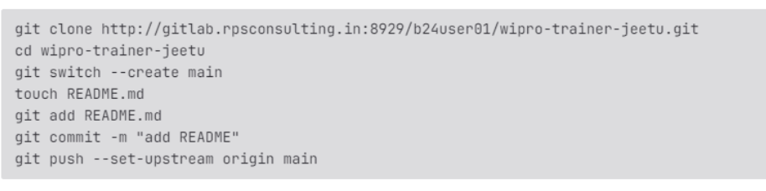

Commands to execute on daily basis:

1. Add all new files to same folder.
2. Then,

# git add .

# git commit -m “some message”

# git push --set-upstream origin main